Getting Started with Rational Rose

Step 1 - Click on Rational Rose Enterprise Edition

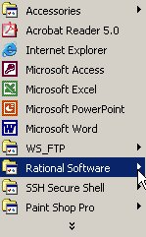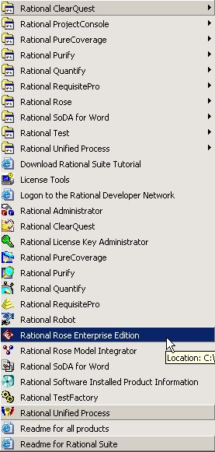

Step 2 - Choose Rational Unified Process for the new model.

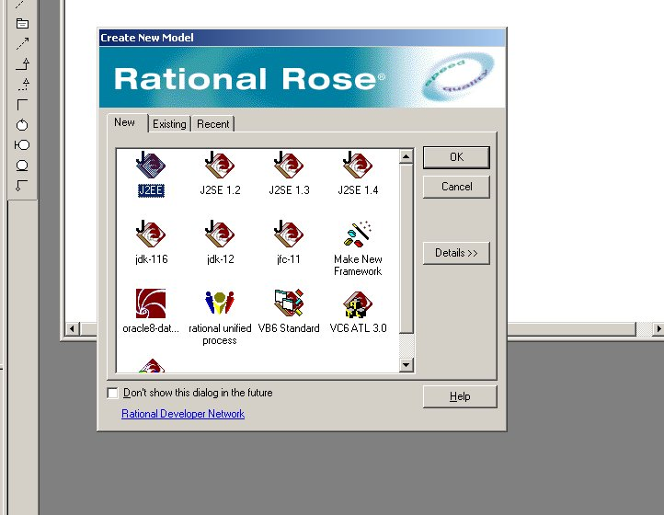

Step 3 – Notice that the model has no title

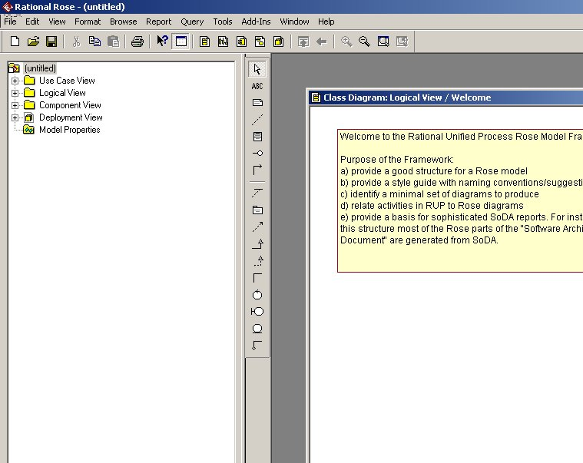
Step 4 – Rename model “blackjack” by right clicking on the name “untitled”

