THE UNIFIED PROCESS
(Chapter 3 - Summary)

REFERENCES

“The Unified Software Development Process,” I. Jacobson, G. Booch, & J. Rumbaugh,
Addison-Wesley 1999, ISBN 0-201-57169-2

“The Rational Unified Process: An Introduction, Second Edition,” Philippe Kruchten,
Addison-Wesley 2000, ISBN 0-201-70710-1

“The Rational Unified Process Made Easy: A Practitioner’s Guide to the RUP,” Per Kroll and Philippe Kruchten, Addison-Wesley 2003, ISBN 0-321-16609-4

“Applying UML and Patterns: An Introduction to Object-Oriented Analysis and Design and
Iterative Development, Third Edition,” Craig Larman, Prentice Hall 2005, ISBN 0-13-148906-2

DEFINITION:

THE UNIFIED PROCESS is: A 2-Dimensional, Object-Oriented, Software-Product-Development Methodology that employs a Risk Driven Iterative & Incremental life-
cycle and the Unified Modeling Language (UML).

WORKFLOWS

CORE WORKFLOWS | Aim | Activities (HOW?)
Requirements  (language of client) | To define, analyze, refine, & document product requirements  (that satisfy client NEEDS) | Chapter 10  Elicitation &  Concept exploration
Analysis & Design  (language of developers)  {Schach treats  Analysis & Design as separate workflows} | To define, analyze, refine, & document the product architecture  To design & document the classes, data structures, & methods needed to implement the architecture  To produce a software project management plan | Chapter 11  OO Analysis  Chapter 12  OO Design  Chapter 9
Implementation | To produce source code | Chapter 13 (~472)
Test | To establish traceability between workflow artifacts  Unit testing  Integration testing  Product testing  Acceptance testing | Chapter 6
NOT A CORE WORKFLOW  Postdelivery maintenance | Regression testing | Chapter 14 (~ 472)

We will not emphasize the BUSINESS CASE in 472.

PHASES (pgs 83 thru 86)

What are the goals of each phase?
What are the outputs of each phase (Deliverables/Artifacts)?

PHASES | Goals | Deliverables
Inception | To achieve concurrence among all stakeholders on product objectives,  to define and baseline the critical system requirements,  and - to determine if the product is economically viable | Vision Document  Software Design Document (Initial)  Plan for Elaboration phase
Elaboration | To define and baseline the architecture of the system,  to refine requirements & risks,  to mitigate critical risks, and  to produce the SPMP | Software Design Document (Almost Complete)  Test Plan/Test code (Initial)  Source code (Initial)  Software Project Management Plan
Construction | Complete the first operational  quality version of the product | Software Design Document (Complete)  Source code (Complete)  Test plan/Test code (Complete)  Software Project Management Plan (Updated)  User Manual(s) (Complete)
Transition | To ensure that the all  requirements have been met and to move the product to the  user community | Software Design Document (Final)  Source code (Final)  Test plan/Test code/Test Report (Final)  User Manual(s) (Final)

The main artifacts evolve continuously throughout all phases.

Software Design Document
Source code
Test plan/Test code

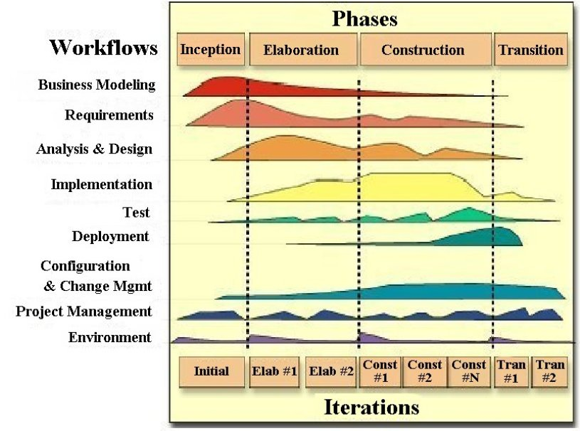

Rational/IBM provides example templates for all documents.
(Templates will be provided for homework in this class)

Vision Document
Vision of requirements
Key features
Main constraints

The CS472 Software Design Document
Domain model (a product glossary)
Business model (a list of product business processes)
Use-case model (use-case diagram & specifications)
Supplementary specifications
Risk ranked list of use cases (& supplementary specs.)
Client acceptance criteria
Baseline product architecture
Initial list of attributes & methods for each class
Risk ranked list of classes

REVIEW
THE ITERATIVE & INCREMENTAL MODEL
(Chapter 2)

INCREMENTS ARE DEFINED IN ORDER OF DECREASING RISK.
(Business risks, Requirements risks, Architectural risks)

ITERATIONS ARE CONDUCTED IN ORDER OF WORKFLOWS, BUT
THE NEED FOR REPETITION IS BASED ON THE FUNDAMENTAL
COMPLEXITY OF THE TASK.
(i.e., Iteration is continued until you have
satisfied the goals of the increment)

CS472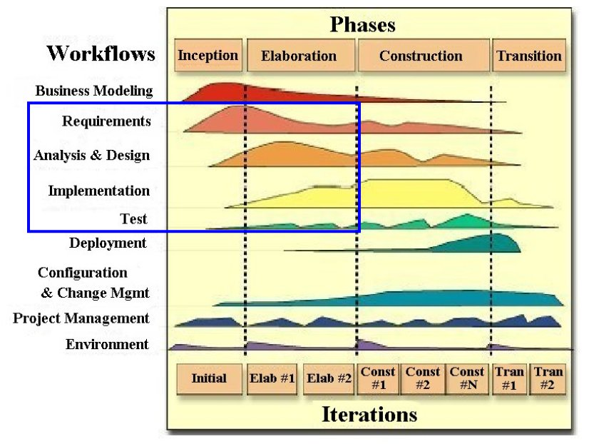
CS 473
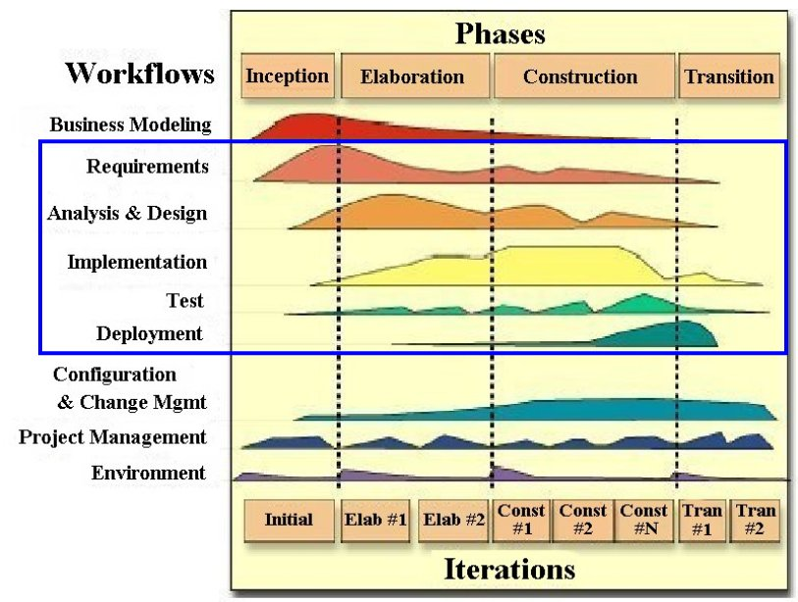
CS 474
