Use Case and Activity Diagrams

- Use Case Diagrams
  - Diagrams with actors, use cases, and relationships among them.
  - There are no strict rules about what to illustrate in use-case diagrams.
- Actors
  - An actor is anything that exchanges data with the system. An actor can be a user, external hardware, or another system.
  - Finding the actors also means that you establish the boundaries of the system, which helps in understanding the purpose and extent of the system.
- Use Cases
  - A sequence of transactions performed by a system that yields a measurable result of value for a particular actor.
  - CRUD (Create, Read, Update, Delete)
  - Often overlooked use cases
    - System start and stop.
    - Maintenance of the system. For example, adding new users and setting up user profiles.
    - Maintenance of data stored in the system. For example, the system is constructed to work in parallel with a legacy system, and data needs to be synchronized between the two.
    - Functionality needed to modify behavior in the system. An example would be functionality for creating new reports.
  - Use Case Specification/Scenario (Flow of events)
    - A description of events needed to accomplish the required behavior of the use case.
    - Remember the flow of events should present what the system does, not how the system is designed to perform the required behavior.
    - Usually defined in the Elaboration phase
- Relationships
  - Between Actors
    - Generalization
      - Shows actor inheritance.
      - Shown by using a solid line with a closed arrowhead.

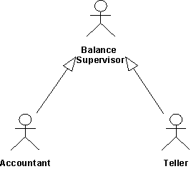

  - Between Actors and Use Cases
    - Communicate-Association
    - A use-case has at most one communicate-association to a specific actor, and an actor has at most one communicate-association to a specific use-case, no matter how many signal transmissions there are.
    - Shown by using a solid line with an open arrowhead.
    - Two way navigability is shown by a solid line with no arrow heads.
  - Between Use Cases
    - Generalization
      - Generalization is used when you find two or more use cases that have commonalities in behavior, structure, and purpose.
      - The child use case is dependent on the structure of the parent use case.

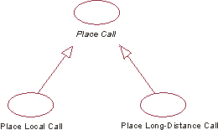

    - Include
      - Used to factor out common or reusable behavior
      - The inclusion use case is not conditional; conditions of execution must be in the base use case.
      - Neither base nor inclusion may access each others attributes.(Encapsulation)
      - Shown by a dashed line with an open arrowhead going from the base use case to the inclusion

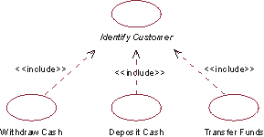

    - Extend
      - Used to show optional behavior
      - The extension use case is conditional; the conditions are described in the extension.
      - The extension use case may access and modify attributes of the base use case, but not the other way around.
      - Shown by a dashed line with an open arrowhead going from extension to the base use case.

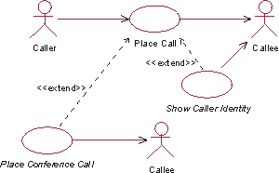

- Activity Diagrams
  - Activity diagram is a special case of a statechart diagram in which all or most of the states are activity states and in which all or most of the of the transitions are triggered by completion of actions in the source states.
  - Two special states
    - Start
    - Stop
  - Activity states, which represent the performance of an activity or step within the flow of events.
  - Transitions that show what activity state follows after another. This type of transition is sometimes referred to as a completion transition, since it differs from a transition in that it does not require an explicit trigger event, it is triggered by the completion of the activity the activity state represents.
  - Decisions for which a set of guard conditions are defined. These guard conditions control which transition (of a set of alternative transitions) follows once the activity has been completed. Decisions and guard conditions allow you to show alternative threads in the flow of events of a use case.
  - Synchronization bars which you can use to show parallel subflows. Synchronization bars allow you to show concurrent threads in the flow of events of a use case.

